12. How to upload the Weekly Wound Photograph

To upload a photograph from the handset, use the ‘Photograph Upload’ interaction.

- Go to the person’s timeline
- Click on the Blue Plus
- In the ‘search’ bar, search for ‘Photograph Upload’
- Click on the ‘Photograph Upload’ interaction
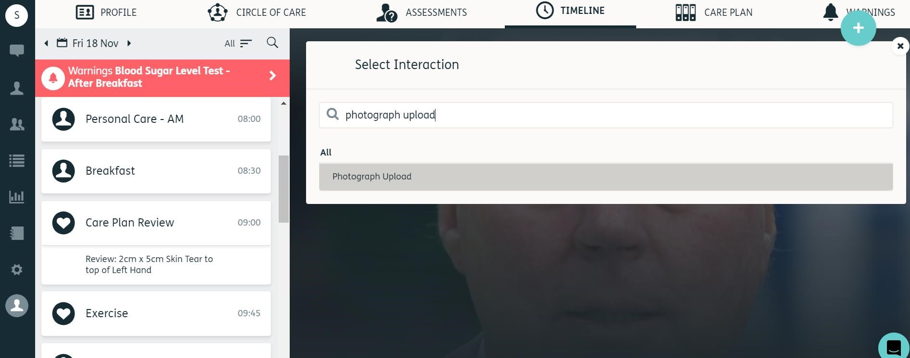

2.
1.
3.
4.

- Use the ‘upload’ icon to choose your photograph.

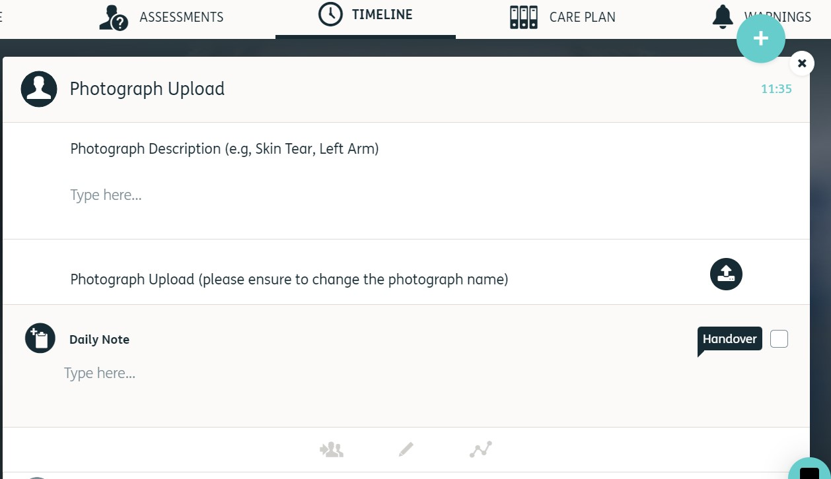

5.

- When you have uploaded the photograph, click the ‘Green Tick’.

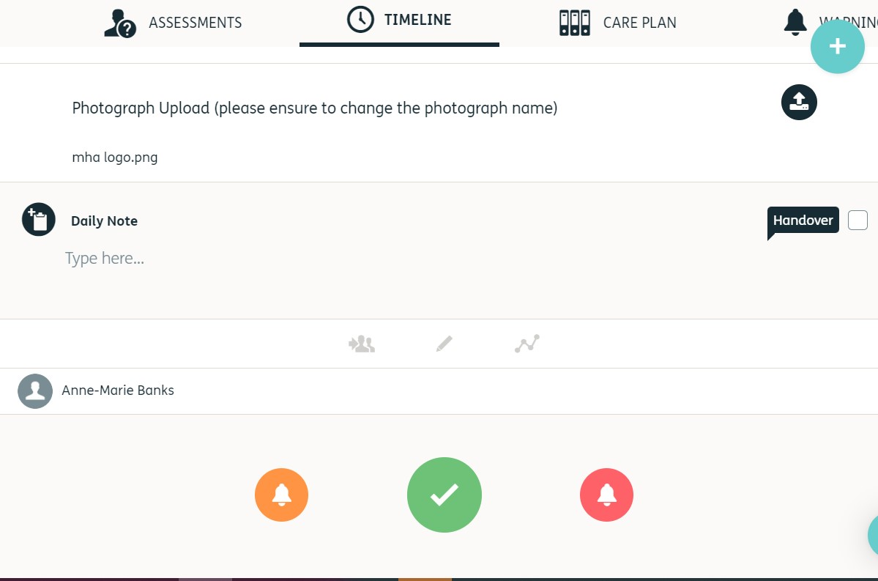

6.

The photograph will be saved under Documents, if the name of the photo does not include a description and date taken this will need to be changed. To change the name of the photograph, follow the steps below.

- Go into the resident’s Profile
- Go into the ‘Documents’ section
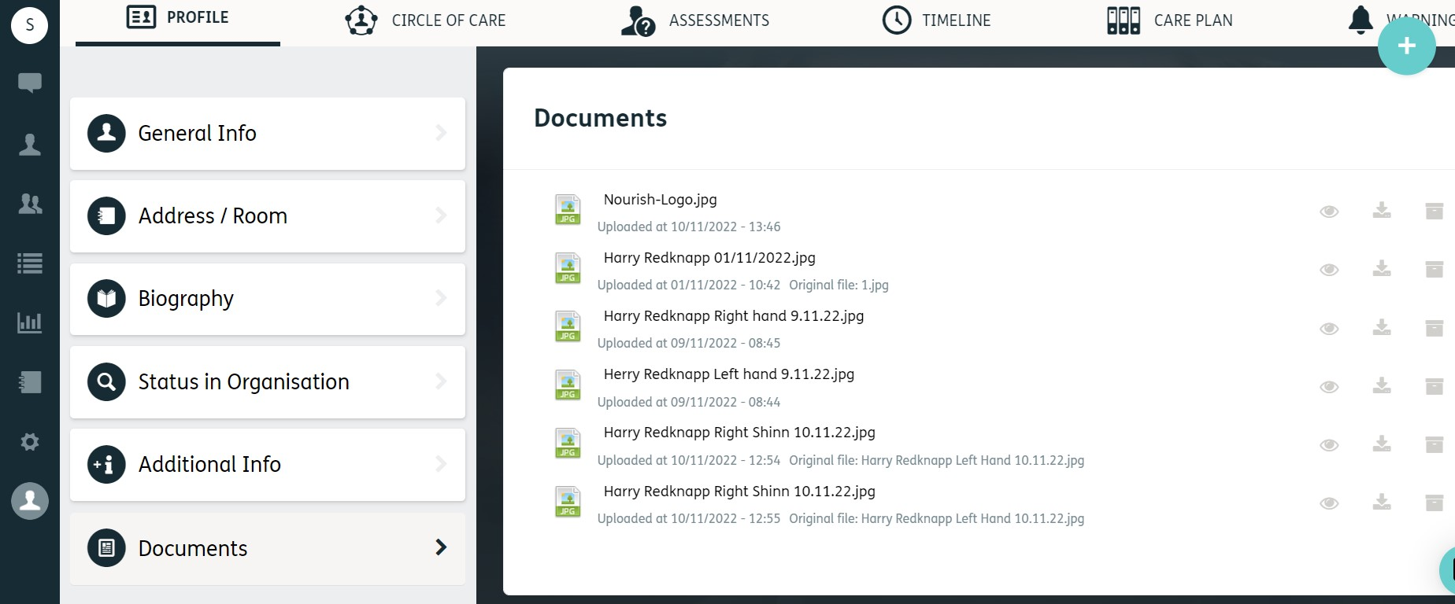

1.
2.

- Hover over the photograph you wish to change the name of and click the ‘pencil’ icon

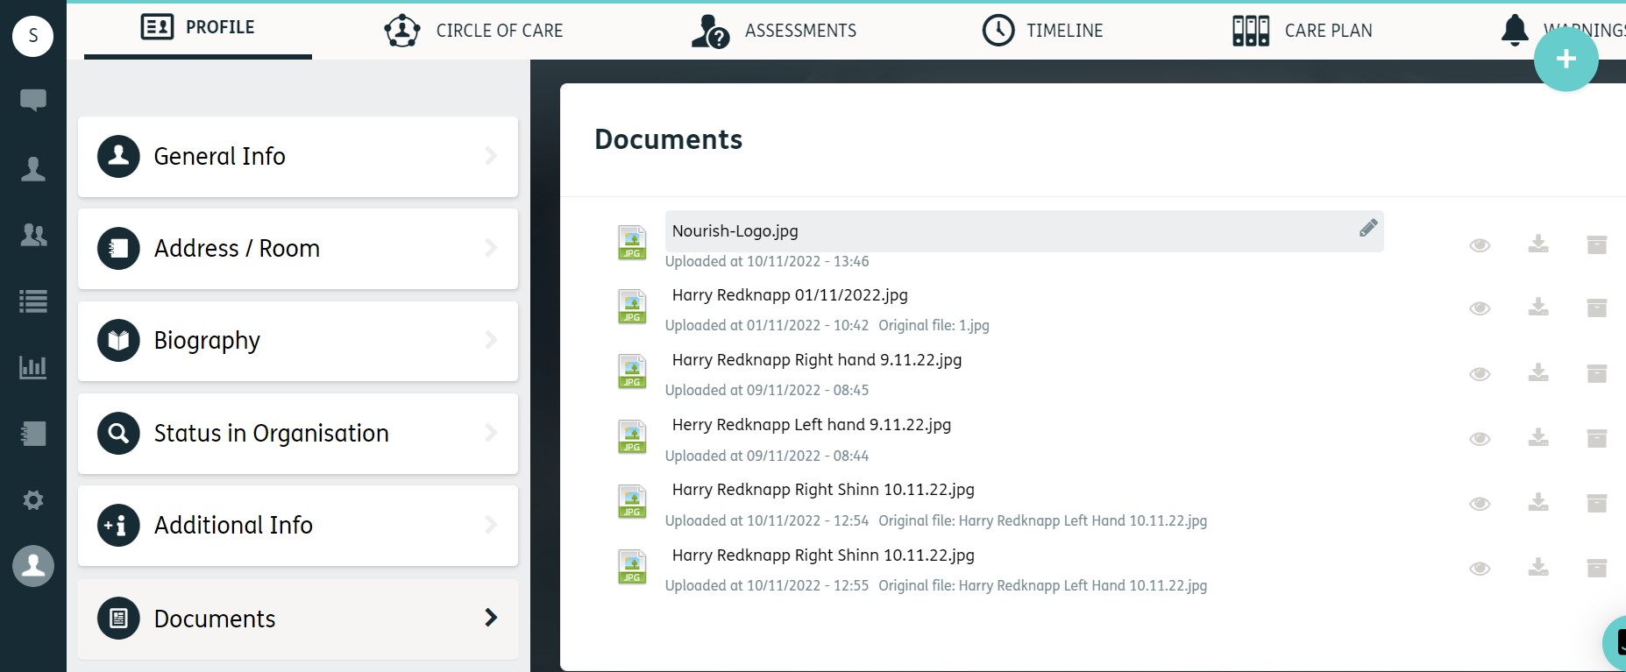

3.

- Highlight the text, delete, and type in the correct description including date taken – this will save automatically

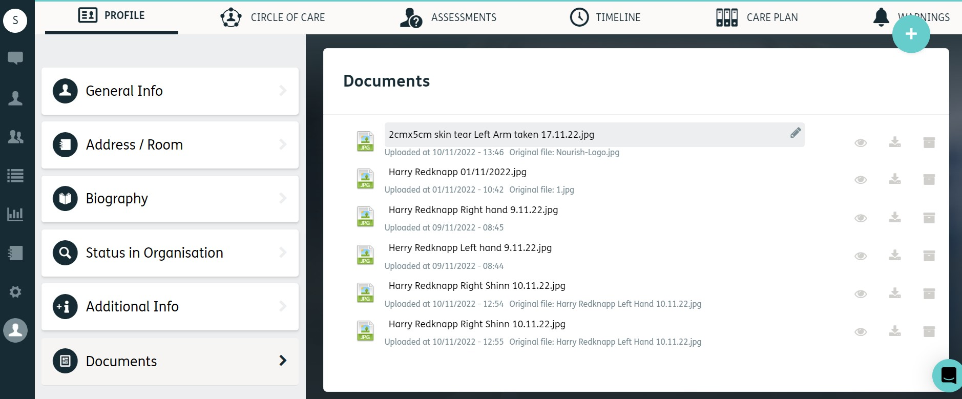

4.

You must then follow the instructions in the no. 13. ‘How to Attach a Supporting Document to a Support Plan’ how to guide to make sure that the weekly photograph is attached and shown under the Wound Care Support Plan.

*Remember that you no longer need to upload Wound photographs into Radar as these are held in Nourish*

